

Memorial Garden

Payment Information:

**There will be a Memorial Garden at the St. Charles County Walk to End Alzheimer’s this year. If you would like to participate in having your loved one in the Memorial Garden please donate towards your team/individual loved one and fill out the information below. Please write their name CLEARLY to avoid any misspelling on the signs. Do not forget to view your sign at the Memorial Garden.**

**Please submit forms to Mary Williams at** [**Marwilliams@alz.org**](mailto:Marwilliams@alz.org) **or Stephanie Orf at** [**srorf@alz.org**](mailto:srorf@alz.org)

Donor Information:

First Name __________________________________ Last Name ___________________________________

Billing Address _________________________ City _________________ State ____________ Zip ___________

Phone ____________________ ____________________Email _______________________________________

$100.00

**Memorial Sign/Take Home**

$50.00

**Memorial Sign**

* **Enclosed is my cash donation.**
* **Enclosed is my check payable to the Alzheimer’s Association.**
* **Please Invoice me.**

**Signature ____________________________________ Date____________________**

In Loving Memory or Loving Support Of:

I am supporting **(circle one):**

1. **A specific loved one who passed with Alzheimer’s.**
2. **A specific loved one who has Alzheimer’s.**
3. **A specific team.**
4. **General in-kind donations to all who had Alzheimer’s – Please write your reason to donate (maximum of 25 letters).**

Loved ones First Name: ____________________________ Last Name: ________________________________

Team Name: _____________________________________ General in-kind Donation ____________________________

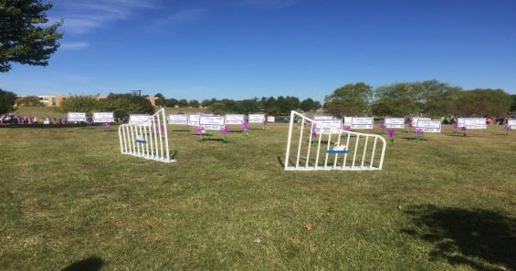

Thank you to our sponsors